1. ***Registration part done git board:***

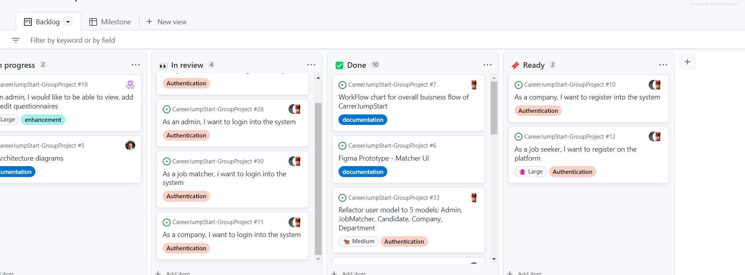

1. ***Registration frontend functionality git:***

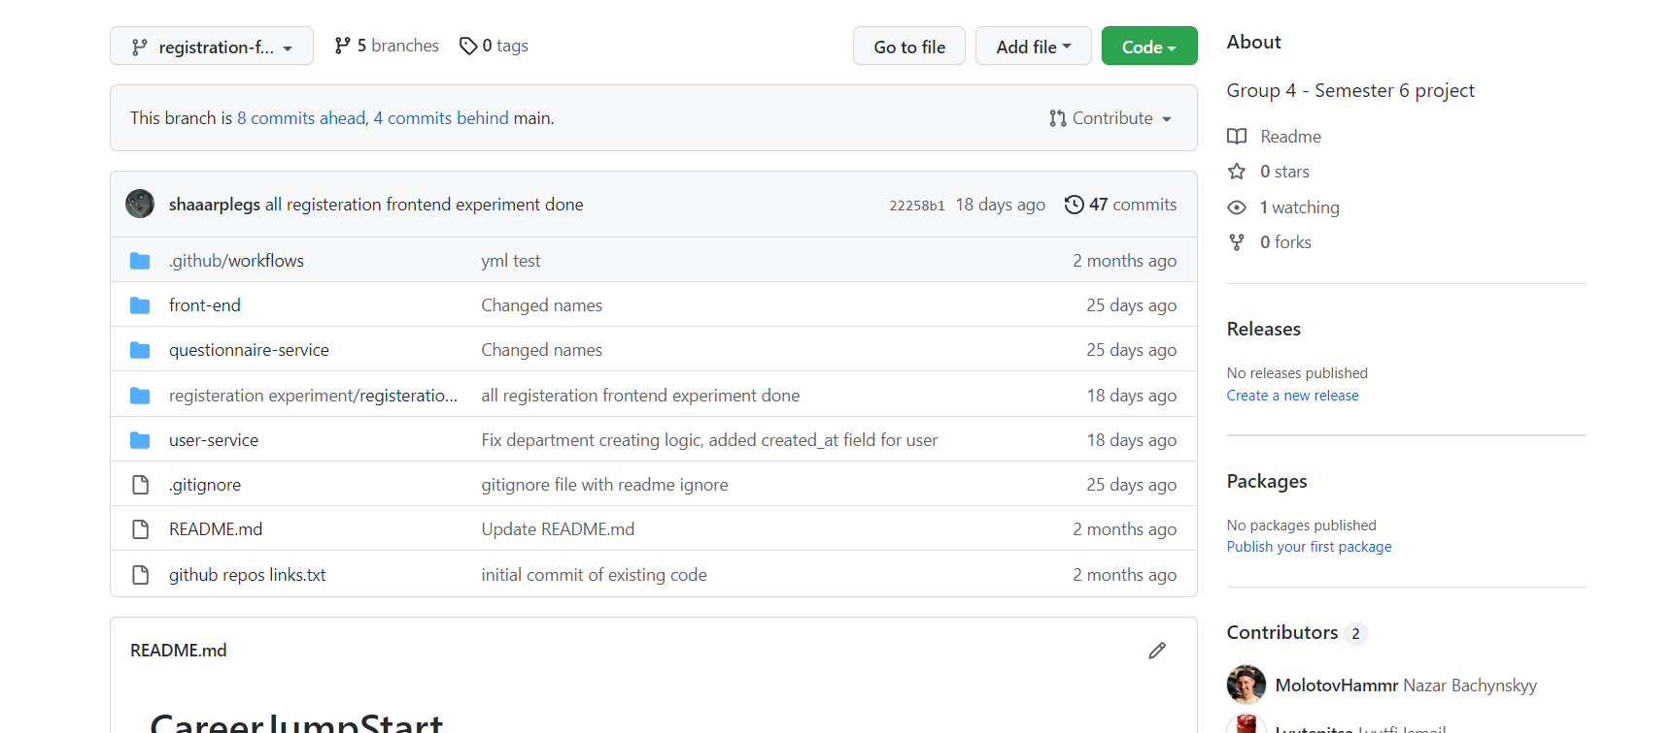

1. ***proof registration in development:***

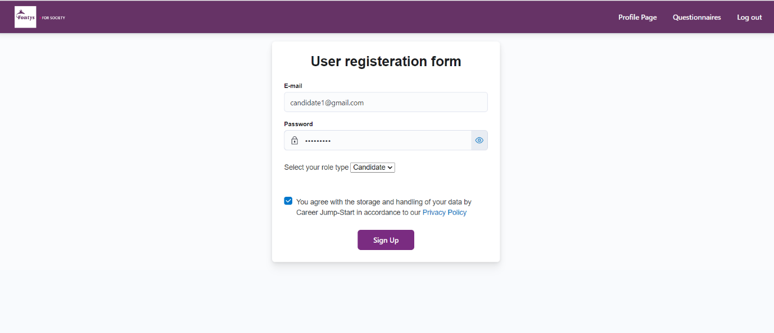

1. ***database registered profile:***

